Study on the use of convolutional neural networks for the diagnosis of atrial fibrillation
Michele Maione
Abstract – In this study we will introduce atrial fibrillation, one of the cardiac arrhythmias, and see how it can be diagnosed using convolutional neural networks in combination with various methods and supervised learning models, including: gray-level co-occurrence matrix, short-time Fourier transform based spectrogram, support-vector machines, k-nearest neighbors, multi-layer perceptron, focal loss, multi-scale decomposition, time-frequency analysis.
Index terms – Biomedical monitoring, electrocardiogram, arrhythmia, atrial fibrillation, deep learning, convolutional neural network, classification.

Introduction
Cardiovascular diseases are a group of diseases affecting the heart and/or blood vessels. On a world level, and in particular in countries with a typically Western lifestyle, cardiovascular diseases are the cause of 17 million deaths per year.
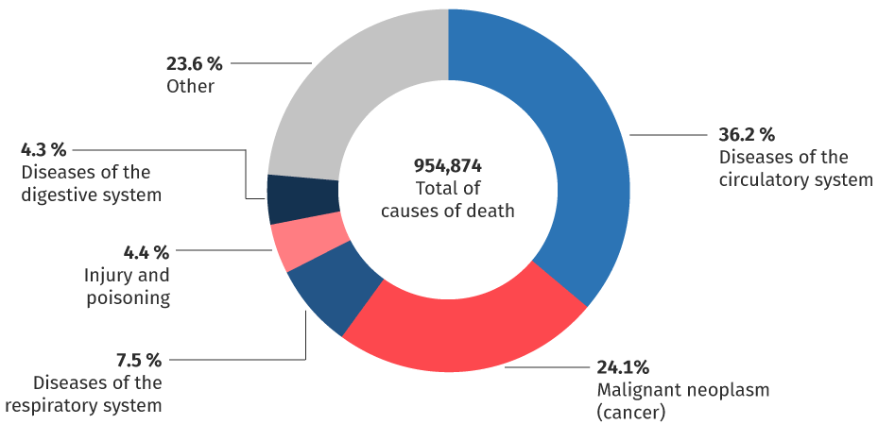Figure 1: common causes of death
The narrowing, obstruction or excessive enlargement (aneurysm) of the blood vessels that can accompany this disease are in fact responsible for very widespread pathologies, such as coronary (angina pectoris and heart attack), cerebrovascular (stroke) and peripheral vascular diseases. In the family of cardiovascular pathologies, all congenital heart defects, rheumatic diseases involving myocardium, various forms of arrhythmia, pathologies affecting the heart valves and heart failure are also included. Cardiac pathologies are divided into: cardiovascular disease, coronary heart disease, heart "muscle" disease, heart valve disease, pericardial disease, heart conduction disease, vessel disease.
In this study we focus on heart conduction disease in particular on atrial fibrillation, one of the two arrhythmias[a].

Arrhythmia
Arrhythmia is a clinical condition in which the normal frequency or regularity of the heart rhythm is missing, or the physiological atrio-ventricular activation sequence is altered. Common symptoms are:
- Extrasystole: it is like a 'void', a missed beat;
- Tachycardia: the sensation is of an increase in beats, which can be regular but also irregular, fatigue, difficult breathing, dizziness;
- Bradycardia: fatigue, dizziness and possible loss of consciousness.
The alterations can have the following origins: at the level of the sinoatrial node, of supraventricular origin, at the level of the atrioventricular node, of ventricular origin. As for the supraventricular and ventricular origins, we have two types of fibrillation: atrial and ventricular[b].

Ventricular fibrillation
Ventricular fibrillation (VF) is a very rapid, chaotic cardiac arrhythmia that causes uncoordinated contractions of the heart muscle. With the onset of this arrhythmia, blood circulation slows down considerably, up to cardiocirculatory arrest and subsequent respiratory arrest, until death if cardioversion of the rhythm is not intervened through defibrillation and cardiopulmonary resuscitation[b].

Atrial fibrillation
Atrial fibrillation (AF) is a cardiac arrhythmia that originates in the atria. The electrical impulses that give rise to the contraction of the atria are activated in a totally chaotic and fragmentary way, giving rise to multiple wave fronts and disorganized and fragmentary contractions. The current clinical approach aims to treat symptoms by:
- rhythm control (i.e. recovery and maintenance of sinus rhythm with anti-arrhythmic drugs or catheter ablation);
- heart rate control with drugs that regulate the conduction of atrial stimuli to the ventricles associated with anti-thrombotic therapy.
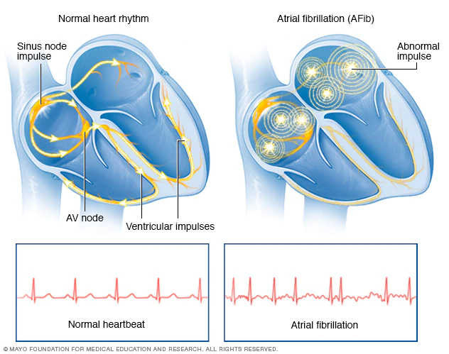Figure 2: normal heartbeat & atrial fibrillation
In general, the electrocardiogram (ECG) signals consist of six components that are designated as P, Q, R, S, T, and U:
- The P wave represents atrial depolarization;
- The QRS complex represents ventricular depolarization;
- The T wave represents ventricular repolarization;
- The U wave represents papillary muscle repolarization.
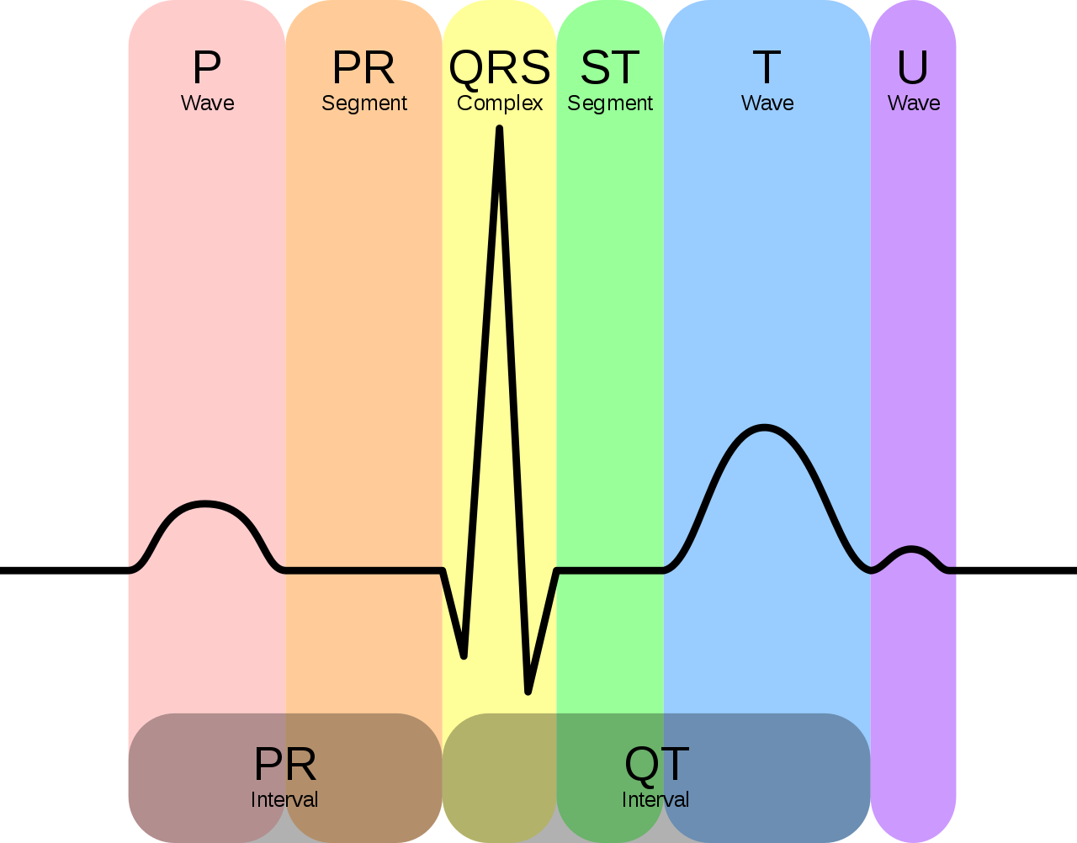Figure 3: schematic representation of a normal ECG
From Figure 4 it can be observed that for AF patient there are tiny irregular fluctuations in the P-wave and QRS complex. Given the presence of these irregularities, for the purpose of arrhythmia screening various morphological features, including the peaks and widths corresponding to different ECG segments are typically used.
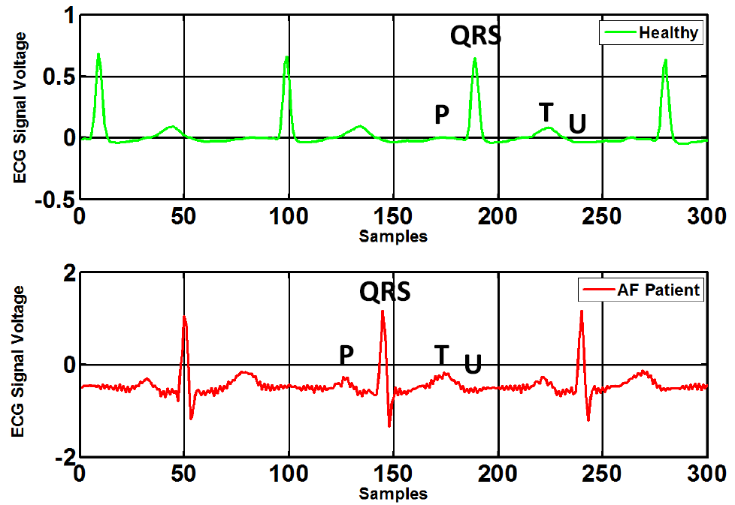Figure 4: ECG signal of healthy person (top) and AF patient (bottom)
AF occurs in 2% of the population, and increases to 6% by the age of 65. The most serious complication of AF is thromboembolic stroke, which leads to permanent disability or even death. Since in many cases the symptoms are initially imperceptible to patients, diagnosing it as soon as possible becomes difficult, for this reason with the current technological progress, diagnostic tools can be included in wearable devices, for example in smart watches or in affordable medical devices[c].

Notation and relevant definitions
We will now introduce the computational models used.

Artificial neural network
An artificial neural network (ANN) is an interconnected group of nodes, inspired by a simplification of neurons in a brain. As in Figure 5 each circular node represents an artificial neuron and a line represents a connection from the output of one artificial neuron to the input of another.
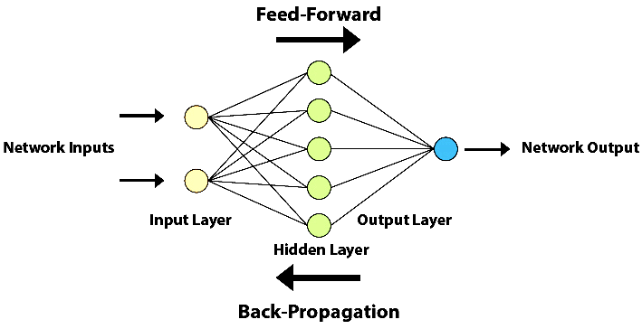Figure 5: artificial neural network scheme
Typically neural networks are obtained through the combination of simple predictor of the form. The functionis known as activation function[12].
To define the neural computation we must specify:
- The neural model;
- The model dimensions;
- The configuration procedure[11].

Neural model
Neural model is composed by activation function and network topology.
Common activation function are: binary step, linear activation, sigmoid, tanH, ReLU, softmax, swish, etc…
The neural network topology represents the way in which neurons are connected to form a network. In other words, the neural network topology can be seen as the relationship between the neurons by means of their connections. The topology of a neural network plays a fundamental role in its functionality and performance. Some famous networks are: feed-forward NN, regulatory feedback networks, radial basis function network, recurrent neural network, modular neural network, etc…

Configuration procedure
Configuration procedure is composed by: configuration algorithm, training set, validation set.
Configuration algorithm must be chosen based on the learning paradigm: supervised, unsupervised, reinforcement.
In supervised learning the data set contain both the data points 𝒳 and the labels 𝒴. The learning task is to produce the desired output y for each input x. A cost function 𝓁 is used to estimate the correctness of the predicted labelcompared to the desired output y.
The simplest division of the data-set is using the Pareto principle, that divide in 80/20 the training and the test set.
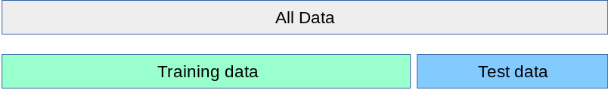Figure 6: 80/20 rule
When evaluating different settings for estimators, there is still a risk of over-fitting on the test set because the parameters can be tweaked until the estimator performs optimally. This way, knowledge about the test set can “leak” into the model and evaluation metrics no longer report on generalization performance. To solve this problem, yet another part of the data-set can be held out as a so-called “validation set”: training proceeds on the training set, after which evaluation is done on the validation set, and when the experiment seems to be successful, final evaluation can be done on the test set.
However, by partitioning the available data into three sets, we drastically reduce the number of samples which can be used for learning the model, and the results can depend on a particular random choice for the pair of (train, validation) sets.
A solution to this problem is a procedure called cross-validation (CV). A test set should still be held out for final evaluation, but the validation set is no longer needed when doing CV. In the basic approach, called K-Fold CV, the training set is split into k smaller sets[f].
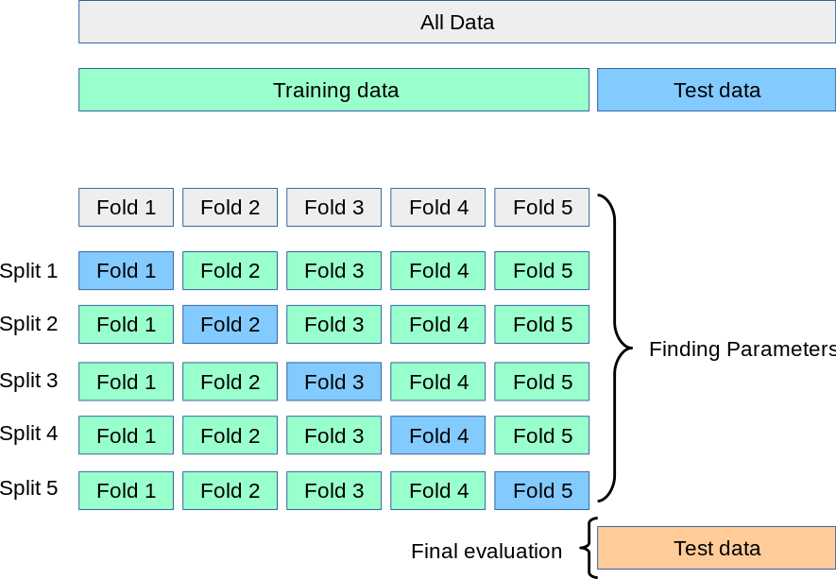Figure 7: K-Fold
Instead unsupervised learning looks for previously undetected patterns in a data set with no pre-existing labels.
Reinforcement learning minimize long-term cost modifying the network’s weights. At each point in time an action is performed and an observation is received with a cost. At this point the algorithm/agent decides whether to perform new actions to uncover their cost or to exploit prior learning. In this case ANN is used as the learning component.

Feed-forward neural network
In a feed-forward neural network connections between units do not form loops and information only moves in one direction, forward, with respect to entry nodes, through hidden nodes (if any) to exit nodes. Feed-forward NN computes a function. A parameter(called weight) is associated with every edge. NNs are trained using algorithms that reduce the training error. Fixed a cost function 𝓁, an example , definedandas the index of a random training example, then the standard training algorithm for NNs is stochastic gradient descent:
(1)
This procedure is known as error back-propagation algorithm[12].

Convolutional neural network
Convolutional neural networks (CNN) function like all feed-forward neural networks: an input layer, one or more hidden layers, which perform calculations using activation functions, and an output layer with the result. The difference is precisely the convolution in place of general matrix multiplication. The typical architecture of a CNN is formed by:
- Convolutional Layer;
- Pooling layer;
- ReLu layer;
- Fully connected layer;
- Loss layer.
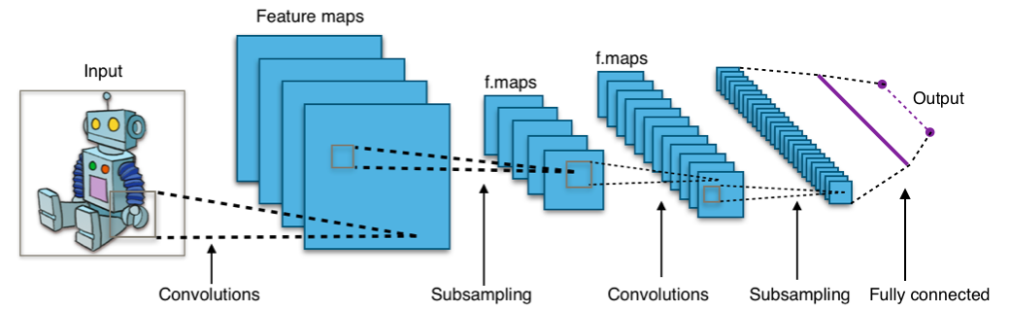Figure 8: typical architecture of a CNN

Convolution
Discrete convolution is an operation between two functions f and h that produce a third function G which consists in integrating the product between the first and the second translated by a certain value. For complex-valued function f and h defined on the set ℤ the discrete convolution G of f and h is given by[e]:
(2)
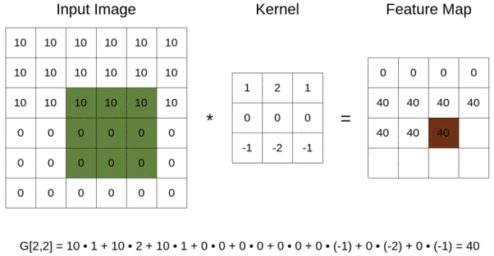Figure 9: convolution

State of the art
We will now introduce the current most widely used methodologies for AF detection.

Time-frequency analysis and CNN
Wu, Lan, Yang, and Nie [1] Lorem ipsum dolor sit amet, consectetur adipiscing elit, sed do eiusmod tempor incididunt ut labore et dolore magna aliqua. Ut enim ad minim veniam, quis nostrud exercitation ullamco laboris nisi ut aliquip ex ea commodo consequat. Duis aute irure dolor in reprehenderit in voluptate velit esse cillum dolore eu fugiat nulla pariatur. Excepteur sint occaecat cupidatat non proident, sunt in culpa qui officia deserunt mollit anim id est laborum. Lorem ipsum dolor sit amet, consectetur adipiscing elit, sed do eiusmod tempor incididunt ut labore et dolore magna aliqua. Ut enim ad minim veniam, quis nostrud exercitation ullamco laboris nisi ut aliquip ex ea commodo consequat. Duis aute irure dolor in reprehenderit in voluptate velit esse cillum dolore eu fugiat nulla pariatur. Excepteur sint occaecat cupidatat non proident, sunt in culpa qui officia deserunt mollit anim id est laborum. Lorem ipsum dolor sit amet, consectetur adipiscing elit, sed do eiusmod tempor incididunt ut labore et dolore magna aliqua. Ut enim ad minim veniam, quis nostrud exercitation ullamco laboris nisi ut aliquip ex ea commodo consequat. Duis aute irure dolor in reprehenderit in voluptate velit esse cillum dolore eu fugiat nulla pariatur. Excepteur sint occaecat cupidatat non proident, sunt in culpa qui officia deserunt mollit anim id est laborum.
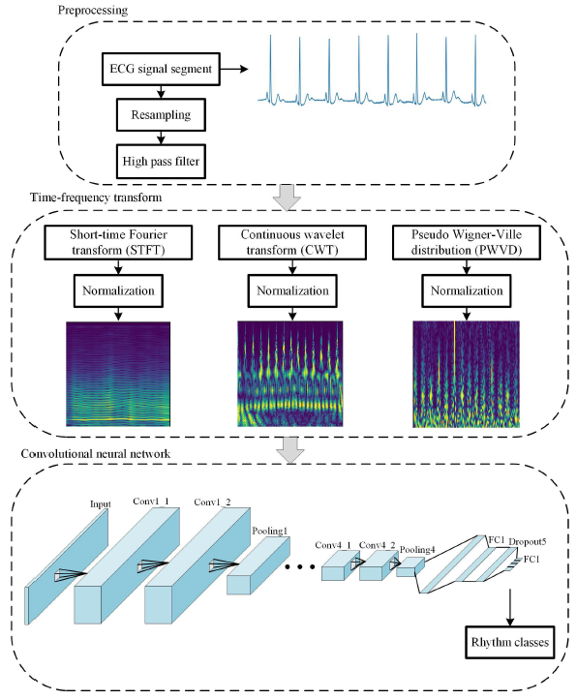Figure 10: the process

Lightweight CNN
Lai, Zhang, Bu, Su and Ma [2] Lorem ipsum dolor sit amet, consectetur adipiscing elit, sed do eiusmod tempor incididunt ut labore et dolore magna aliqua. Ut enim ad minim veniam, quis nostrud exercitation ullamco laboris nisi ut aliquip ex ea commodo consequat. Duis aute irure dolor in reprehenderit in voluptate velit esse cillum dolore eu fugiat nulla pariatur. Excepteur sint occaecat cupidatat non proident, sunt in culpa qui officia deserunt mollit anim id est laborum.
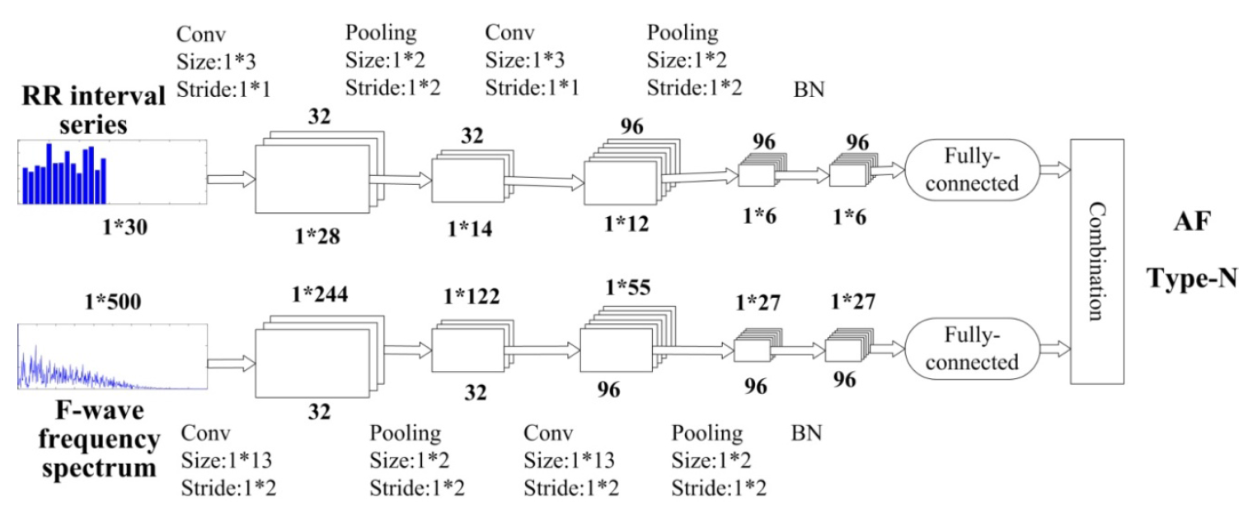Figure 11: lightweight CNN

Multi-scale decomposition enhanced residual CNN
Cao, Yao and Chen [3] Lorem ipsum dolor sit amet, consectetur adipiscing elit, sed do eiusmod tempor incididunt ut labore et dolore magna aliqua. Ut enim ad minim veniam, quis nostrud exercitation ullamco laboris nisi ut aliquip ex ea commodo consequat. Duis aute irure dolor in reprehenderit in voluptate velit esse cillum dolore eu fugiat nulla pariatur. Excepteur sint occaecat cupidatat non proident, sunt in culpa qui officia deserunt mollit anim id est laborum. Lorem ipsum dolor sit amet, consectetur adipiscing elit, sed do eiusmod tempor incididunt ut labore et dolore magna aliqua. Ut enim ad minim veniam, quis nostrud exercitation ullamco laboris nisi ut aliquip ex ea commodo consequat. Duis aute irure dolor in reprehenderit in voluptate velit esse cillum dolore eu fugiat nulla pariatur. Excepteur sint occaecat cupidatat non proident, sunt in culpa qui officia deserunt mollit anim id est laborum.
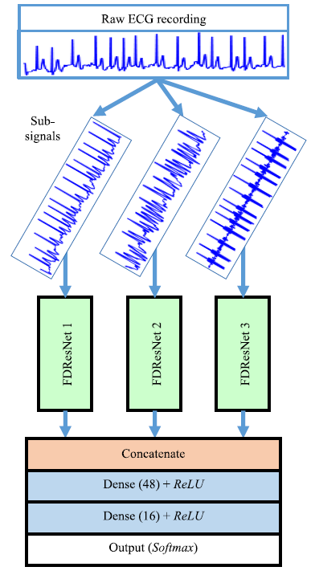Figure 12: multi-scale FDResNet

Dual heartbeat coupling based on CNN
Zhai and Tin [4] Lorem ipsum dolor sit amet, consectetur adipiscing elit, sed do eiusmod tempor incididunt ut labore et dolore magna aliqua. Ut enim ad minim veniam, quis nostrud exercitation ullamco laboris nisi ut aliquip ex ea commodo consequat. Duis aute irure dolor in reprehenderit in voluptate velit esse cillum dolore eu fugiat nulla pariatur. Excepteur sint occaecat cupidatat non proident, sunt in culpa qui officia deserunt mollit anim id est laborum.
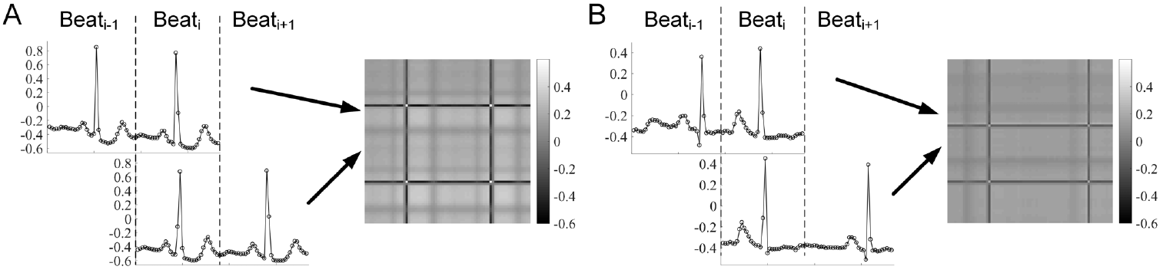Figure 13: Dual-beat coupling matrix computed from two pairs of adjacent beats. A) Coupling matrix of beats originating from the sinus mode. B) Coupling matrix from a supraventricular ectopic beat.

CNN with SVM
Li, Feng, Wu, Yang, Bai and Yang [5] Lorem ipsum dolor sit amet, consectetur adipiscing elit, sed do eiusmod tempor incididunt ut labore et dolore magna aliqua. Ut enim ad minim veniam, quis nostrud exercitation ullamco laboris nisi ut aliquip ex ea commodo consequat. Duis aute irure dolor in reprehenderit in voluptate velit esse cillum dolore eu fugiat nulla pariatur. Excepteur sint occaecat cupidatat non proident, sunt in culpa qui officia deserunt mollit anim id est laborum.
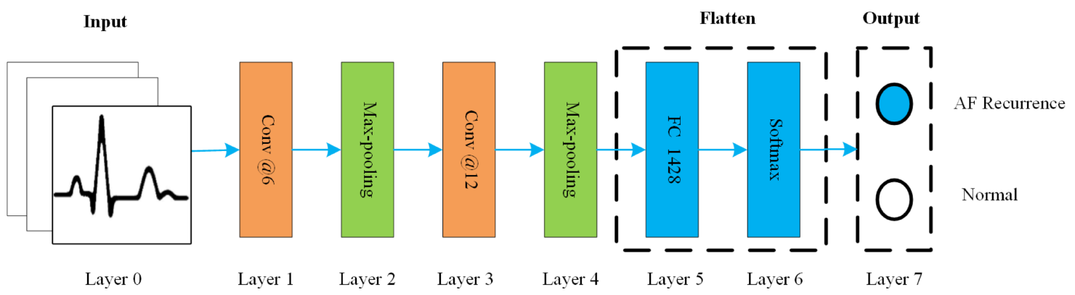Figure 14: CNN architecture

Deep CNN
Pourbabaee, Roshtkhari and Khorasani [6] Lorem ipsum dolor sit amet, consectetur adipniscing elit, sed do eiusmod tempor incididunt ut labore et dolore magna aliqua. Ut enim ad minim veniam, quis nostrud exercitation ullamco laboris nisi ut aliquip ex ea commodo consequat. Duis aute irure dolor in reprehenderit in voluptate velit esse cillum dolore eu fugiat nulla pariatur. Excepteur sint occaecat cupidatat non proident, sunt in culpa qui officia deserunt mollit anim id est laborum.
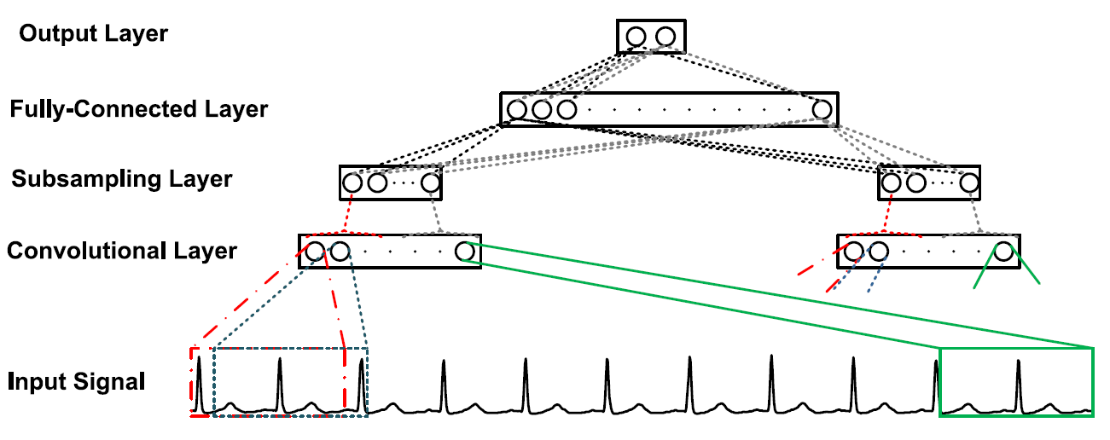Figure 15: overall structure of the CNN

Dense CNN with focal loss and image generation
Al Rahhal, Bazi, Almubarak, Alajlan and Al Zuair [7] Lorem ipsum dolor sit amet, consectetur adipiscing elit, sed do eiusmod tempor incididunt ut labore et dolore magna aliqua. Ut enim ad minim veniam, quis nostrud exercitation ullamco laboris nisi ut aliquip ex ea commodo consequat. Duis aute irure dolor in reprehenderit in voluptate velit esse cillum dolore eu fugiat nulla pariatur. Excepteur sint occaecat cupidatat non proident, sunt in culpa qui officia deserunt mollit anim id est laborum.
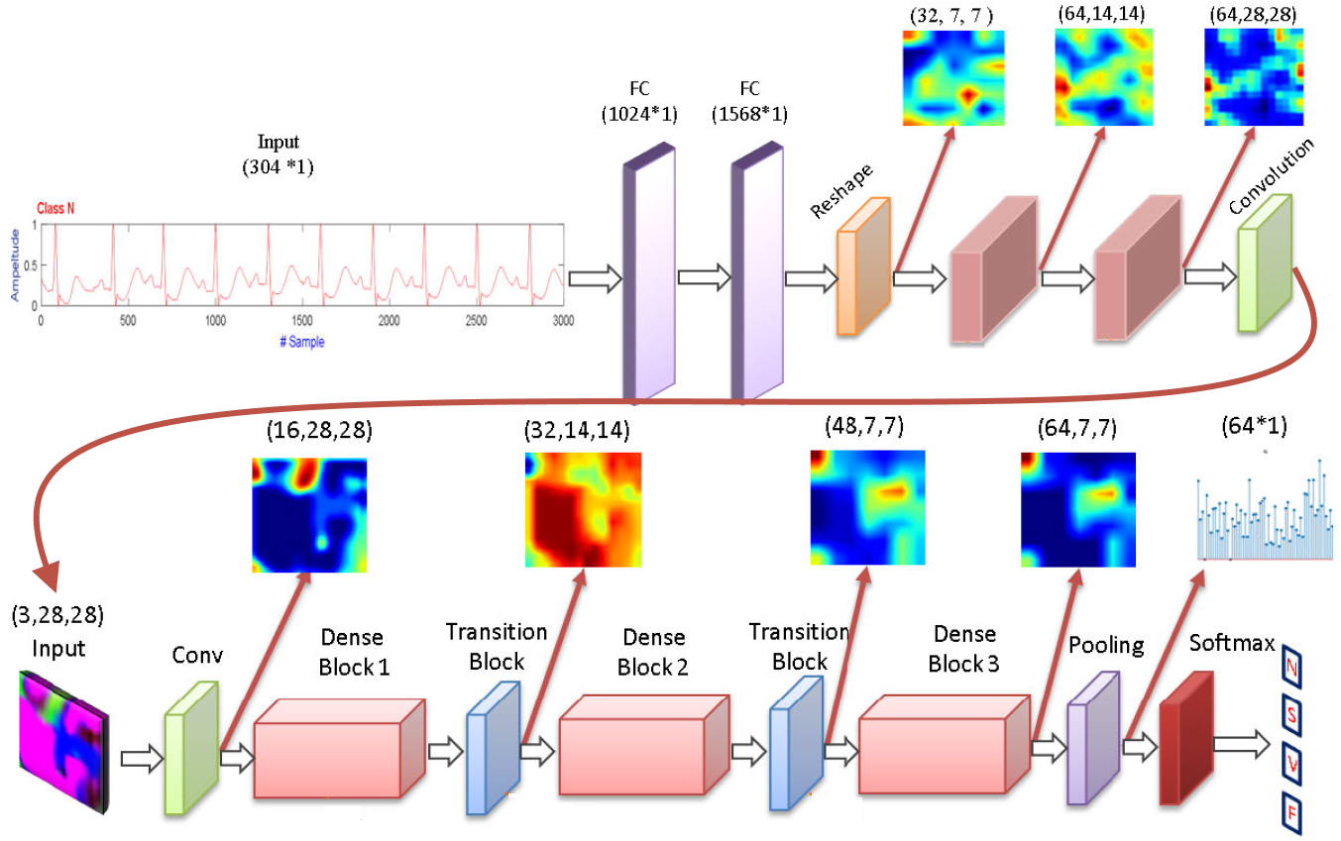Figure 16: generator network & discriminative module

STFT-based spectrogram and CNN
Huang, Chen, Yao and He [8] Lorem ipsum dolor sit amet, consectetur adipiscing elit, sed do eiusmod tempor incididunt ut labore et dolore magna aliqua. Ut enim ad minim veniam, quis nostrud exercitation ullamco laboris nisi ut aliquip ex ea commodo consequat. Duis aute irure dolor in reprehenderit in voluptate velit esse cillum dolore eu fugiat nulla pariatur. Excepteur sint occaecat cupidatat non proident, sunt in culpa qui officia deserunt mollit anim id est laborum.
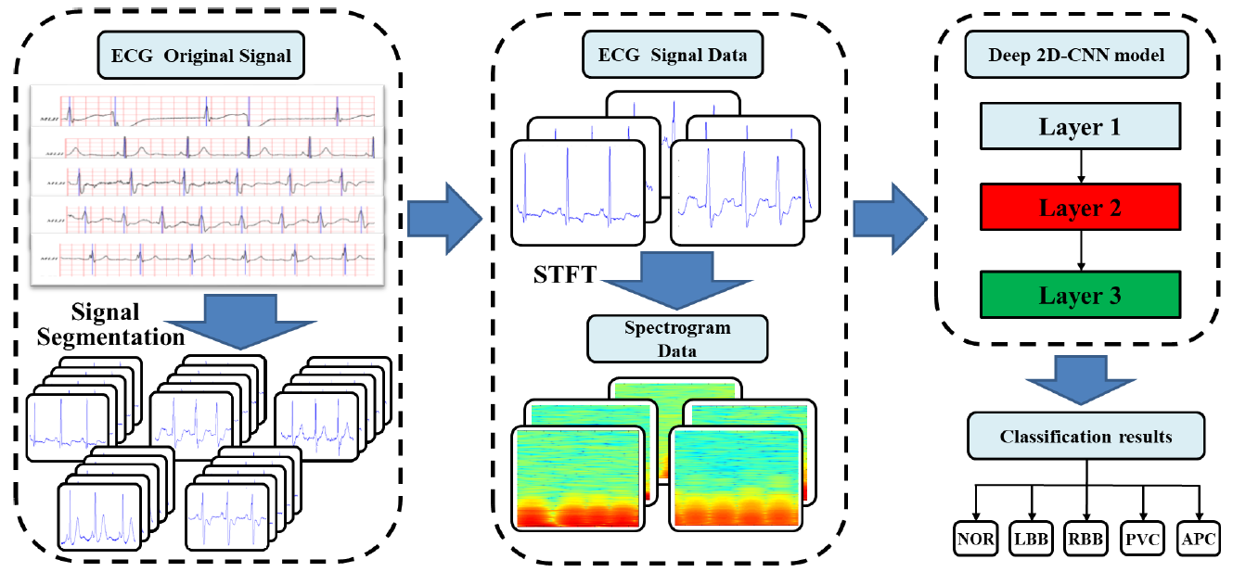Figure 17: 2D-CNN using STFT-based spectrogram

Gray-level co-occurrence matrix enhanced CNN
Sun, Zeng and He [9] Lorem ipsum dolor sit amet, consectetur adipiscing elit, sed do eiusmod tempor incididunt ut labore et dolore magna aliqua. Ut enim ad minim veniam, quis nostrud exercitation ullamco laboris nisi ut aliquip ex ea commodo consequat. Duis aute irure dolor in reprehenderit in voluptate velit esse cillum dolore eu fugiat nulla pariatur. Excepteur sint occaecat cupidatat non proident, sunt in culpa qui officia deserunt mollit anim id est laborum.
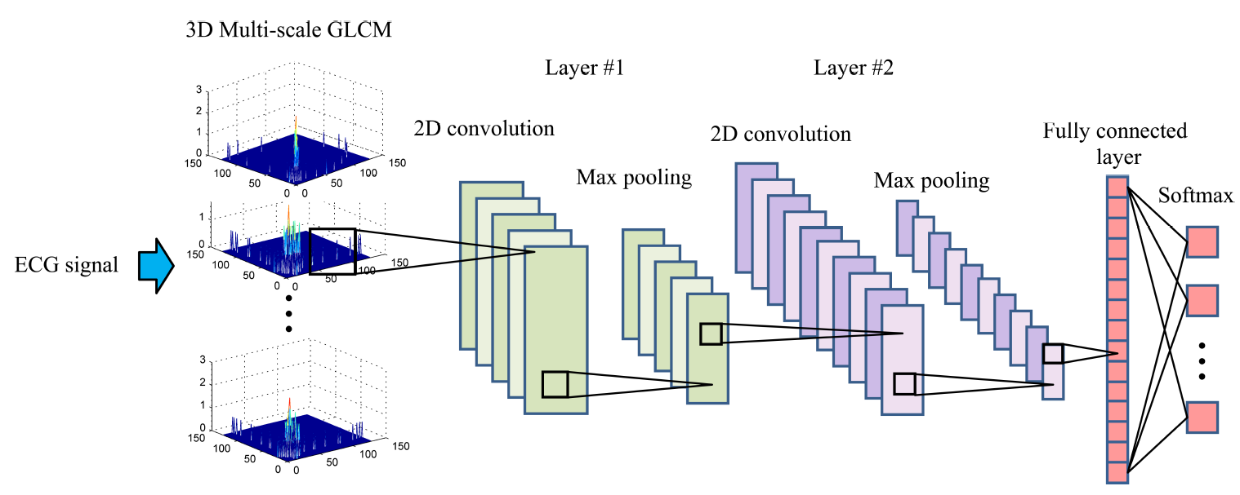Figure 18: general architecture

Multiscaled fusion of deep CNN
Fan, Yao, Cai, Miao, Sun and Li [10] Lorem ipsum dolor sit amet, consectetur adipiscing elit, sed do eiusmod tempor incididunt ut labore et dolore magna aliqua. Ut enim ad minim veniam, quis nostrud exercitation ullamco laboris nisi ut aliquip ex ea commodo consequat. Duis aute irure dolor in reprehenderit in voluptate velit esse cillum dolore eu fugiat nulla pariatur. Excepteur sint occaecat cupidatat non proident, sunt in culpa qui officia deserunt mollit anim id est laborum.
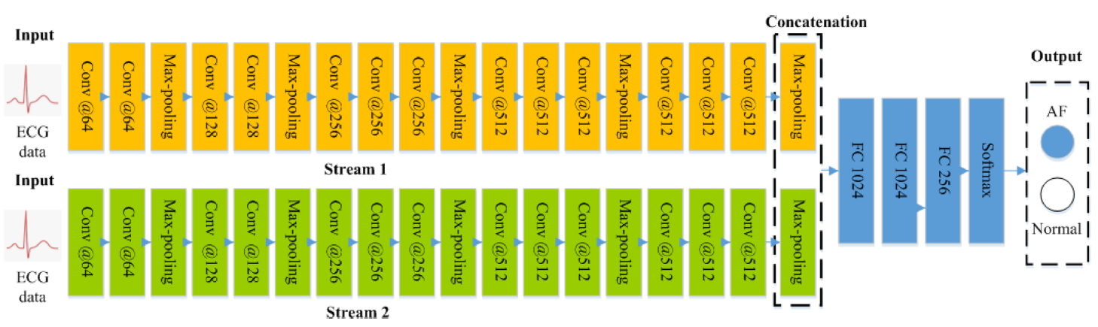Figure 19: architecture of the MS-CNN

Results
Lorem ipsum dolor sit amet, consectetur adipiscing elit, sed do eiusmod tempor incididunt ut labore et dolore magna aliqua. Ut enim ad minim veniam, quis nostrud exercitation ullamco laboris nisi ut aliquip ex ea commodo consequat. Duis aute irure dolor in reprehenderit in voluptate velit esse cillum dolore eu fugiat nulla pariatur. Excepteur sint occaecat cupidatat non proident, sunt in culpa qui officia deserunt mollit anim id est laborum.
Lorem ipsum dolor sit amet, consectetur adipiscing elit, sed do eiusmod tempor incididunt ut labore et dolore magna aliqua. Ut enim ad minim veniam, quis nostrud exercitation ullamco laboris nisi ut aliquip ex ea commodo consequat. Duis aute irure dolor in reprehenderit in voluptate velit esse cillum dolore eu fugiat nulla pariatur. Excepteur sint occaecat cupidatat non proident, sunt in culpa qui officia deserunt mollit anim id est laborum.
Lorem ipsum dolor sit amet, consectetur adipiscing elit, sed do eiusmod tempor incididunt ut labore et dolore magna aliqua. Ut enim ad minim veniam, quis nostrud exercitation ullamco laboris nisi ut aliquip ex ea commodo consequat. Duis aute irure dolor in reprehenderit in voluptate velit esse cillum dolore eu fugiat nulla pariatur. Excepteur sint occaecat cupidatat non proident, sunt in culpa qui officia deserunt mollit anim id est laborum.
Lorem ipsum dolor sit amet, consectetur adipiscing elit, sed do eiusmod tempor incididunt ut labore et dolore magna aliqua. Ut enim ad minim veniam, quis nostrud exercitation ullamco laboris nisi ut aliquip ex ea commodo consequat. Duis aute irure dolor in reprehenderit in voluptate velit esse cillum dolore eu fugiat nulla pariatur. Excepteur sint occaecat cupidatat non proident, sunt in culpa qui officia deserunt mollit anim id est laborum.
Lorem ipsum dolor sit amet, consectetur adipiscing elit, sed do eiusmod tempor incididunt ut labore et dolore magna aliqua. Ut enim ad minim veniam, quis nostrud exercitation ullamco laboris nisi ut aliquip ex ea commodo consequat. Duis aute irure dolor in reprehenderit in voluptate velit esse cillum dolore eu fugiat nulla pariatur. Excepteur sint occaecat cupidatat non proident, sunt in culpa qui officia deserunt mollit anim id est laborum.
Lorem ipsum dolor sit amet, consectetur adipiscing elit, sed do eiusmod tempor incididunt ut labore et dolore magna aliqua. Ut enim ad minim veniam, quis nostrud exercitation ullamco laboris nisi ut aliquip ex ea commodo consequat. Duis aute irure dolor in reprehenderit in voluptate velit esse cillum dolore eu fugiat nulla pariatur. Excepteur sint occaecat cupidatat non proident, sunt in culpa qui officia deserunt mollit anim id est laborum.
Lorem ipsum dolor sit amet, consectetur adipiscing elit, sed do eiusmod tempor incididunt ut labore et dolore magna aliqua. Ut enim ad minim veniam, quis nostrud exercitation ullamco laboris nisi ut aliquip ex ea commodo consequat. Duis aute irure dolor in reprehenderit in voluptate velit esse cillum dolore eu fugiat nulla pariatur. Excepteur sint occaecat cupidatat non proident, sunt in culpa qui officia deserunt mollit anim id est laborum.
Lorem ipsum dolor sit amet, consectetur adipiscing elit, sed do eiusmod tempor incididunt ut labore et dolore magna aliqua. Ut enim ad minim veniam, quis nostrud exercitation ullamco laboris nisi ut aliquip ex ea commodo consequat. Duis aute irure dolor in reprehenderit in voluptate velit esse cillum dolore eu fugiat nulla pariatur. Excepteur sint occaecat cupidatat non proident, sunt in culpa qui officia deserunt mollit anim id est laborum.
Lorem ipsum dolor sit amet, consectetur adipiscing elit, sed do eiusmod tempor incididunt ut labore et dolore magna aliqua. Ut enim ad minim veniam, quis nostrud exercitation ullamco laboris nisi ut aliquip ex ea commodo consequat. Duis aute irure dolor in reprehenderit in voluptate velit esse cillum dolore eu fugiat nulla pariatur. Excepteur sint occaecat cupidatat non proident, sunt in culpa qui officia deserunt mollit anim id est laborum.
Lorem ipsum dolor sit amet, consectetur adipiscing elit, sed do eiusmod tempor incididunt ut labore et dolore magna aliqua. Ut enim ad minim veniam, quis nostrud exercitation ullamco laboris nisi ut aliquip ex ea commodo consequat. Duis aute irure dolor in reprehenderit in voluptate velit esse cillum dolore eu fugiat nulla pariatur. Excepteur sint occaecat cupidatat non proident, sunt in culpa qui officia deserunt mollit anim id est laborum.

Discussion
Lorem ipsum dolor sit amet, consectetur adipiscing elit, sed do eiusmod tempor incididunt ut labore et dolore magna aliqua. Ut enim ad minim veniam, quis nostrud exercitation ullamco laboris nisi ut aliquip ex ea commodo consequat. Duis aute irure dolor in reprehenderit in voluptate velit esse cillum dolore eu fugiat nulla pariatur. Excepteur sint occaecat cupidatat non proident, sunt in culpa qui officia deserunt mollit anim id est laborum.
Lorem ipsum dolor sit amet, consectetur adipiscing elit, sed do eiusmod tempor incididunt ut labore et dolore magna aliqua. Ut enim ad minim veniam, quis nostrud exercitation ullamco laboris nisi ut aliquip ex ea commodo consequat. Duis aute irure dolor in reprehenderit in voluptate velit esse cillum dolore eu fugiat nulla pariatur. Excepteur sint occaecat cupidatat non proident, sunt in culpa qui officia deserunt mollit anim id est laborum.
Lorem ipsum dolor sit amet, consectetur adipiscing elit, sed do eiusmod tempor incididunt ut labore et dolore magna aliqua. Ut enim ad minim veniam, quis nostrud exercitation ullamco laboris nisi ut aliquip ex ea commodo consequat. Duis aute irure dolor in reprehenderit in voluptate velit esse cillum dolore eu fugiat nulla pariatur. Excepteur sint occaecat cupidatat non proident, sunt in culpa qui officia deserunt mollit anim id est laborum.
Lorem ipsum dolor sit amet, consectetur adipiscing elit, sed do eiusmod tempor incididunt ut labore et dolore magna aliqua. Ut enim ad minim veniam, quis nostrud exercitation ullamco laboris nisi ut aliquip ex ea commodo consequat. Duis aute irure dolor in reprehenderit in voluptate velit esse cillum dolore eu fugiat nulla pariatur. Excepteur sint occaecat cupidatat non proident, sunt in culpa qui officia deserunt mollit anim id est laborum.
Lorem ipsum dolor sit amet, consectetur adipiscing elit, sed do eiusmod tempor incididunt ut labore et dolore magna aliqua. Ut enim ad minim veniam, quis nostrud exercitation ullamco laboris nisi ut aliquip ex ea commodo consequat. Duis aute irure dolor in reprehenderit in voluptate velit esse cillum dolore eu fugiat nulla pariatur. Excepteur sint occaecat cupidatat non proident, sunt in culpa qui officia deserunt mollit anim id est laborum.

Conclusion
Lorem ipsum dolor sit amet, consectetur adipiscing elit, sed do eiusmod tempor incididunt ut labore et dolore magna aliqua. Ut enim ad minim veniam, quis nostrud exercitation ullamco laboris nisi ut aliquip ex ea commodo consequat. Duis aute irure dolor in reprehenderit in voluptate velit esse cillum dolore eu fugiat nulla pariatur. Excepteur sint occaecat cupidatat non proident, sunt in culpa qui officia deserunt mollit anim id est laborum.
Lorem ipsum dolor sit amet, consectetur adipiscing elit, sed do eiusmod tempor incididunt ut labore et dolore magna aliqua. Ut enim ad minim veniam, quis nostrud exercitation ullamco laboris nisi ut aliquip ex ea commodo consequat. Duis aute irure dolor in reprehenderit in voluptate velit esse cillum dolore eu fugiat nulla pariatur. Excepteur sint occaecat cupidatat non proident, sunt in culpa qui officia deserunt mollit anim id est laborum.
Lorem ipsum dolor sit amet, consectetur adipiscing elit, sed do eiusmod tempor incididunt ut labore et dolore magna aliqua. Ut enim ad minim veniam, quis nostrud exercitation ullamco laboris nisi ut aliquip ex ea commodo consequat. Duis aute irure dolor in reprehenderit in voluptate velit esse cillum dolore eu fugiat nulla pariatur. Excepteur sint occaecat cupidatat non proident, sunt in culpa qui officia deserunt mollit anim id est laborum.

References
- Ziqian Wu, Tianjie Lan, Cuiwei Yang, and Zhenning Nie, “A Novel Method to Detect Multiple Arrhythmias Based on Time-Frequency Analysis and Convolutional Neural Networks”, IEEE Access, vol. 7, pp. 170820-170830, December 2019
- Dakun Lai, Xinshu Zhang, Yuxiang Bu, Ye Su, and Chang-sheng Ma, “An Automatic System for Real-Time Identifying Atrial Fibrillation by Using a Lightweight Convolutional Neural Network”, IEEE Access, vol. 7, pp. 130074-130084, December 2019
- Xin-cheng Cao, Bin Yao, and Bin-qiang Chen, “Atrial Fibrillation Detection Using an Improved Multi-Scale Decomposition Enhanced Residual Convolutional Neural Network”, IEEE Access, vol. 7, pp. 89152-89161, December 2019
- Xiaolong Zhai, and Chung Tin, “Automated ECG Classification Using Dual Heartbeat Coupling Based on Convolutional Neural Network”, IEEE Access, vol. 6, pp. 27465-27472, June 2018
- Zhangjun Li, Xujian Feng, Ziqian Wu, Cuiwei Yang, Baodan Bai, and Qunqing Yang, “Classification of Atrial Fibrillation Recurrence Based on a Convolution Neural Network With SVM Architecture”, IEEE Access, vol. 7, pp. 77849-77856, December 2019
- Bahareh Pourbabaee, Mehrsan Javan Roshtkhari, and Khashayar Khorasani, “Deep Convolutional Neural Networks and Learning ECG Features for Screening Paroxysmal Atrial Fibrillation Patients”, IEEE Transactions On Systems, Man, And Cybernetics: Systems, vol. 48, n. 12, pp. 2095-2104, December 2018
- Mohamad Mahmoud Al Rahhal, Yakoub Bazi, Haidar Almubarak, Naif Alajlan, and Mansour Al Zuair, “Dense Convolutional Networks With Focal Loss and Image Generation for Electrocardiogram Classification”, IEEE Access, vol. 7, pp. 182225-182237, December 2019
- Jingshan Huang, Binqiang Chen, Bin Yao, and Wangpeng He, “ECG Arrhythmia Classification Using STFT-Based Spectrogram and Convolutional Neural Network”, IEEE Access, vol. 7, pp. 92871-92880, July 2019
- Weifang Sun, Nianyin Zeng, and Yuchao He, “Morphological Arrhythmia Automated Diagnosis Method Using Gray-Level Co-Occurrence Matrix Enhanced Convolutional Neural Network”, IEEE Access, vol. 7, pp. 67123-67129, June 2019
- Xiaomao Fan, Qihang Yao, Yunpeng Cai, Fen Miao, Fangmin Sun, and Ye Li, “Multiscaled Fusion of Deep Convolutional Neural Networks for Screening Atrial Fibrillation From Single Lead Short ECG Recordings”, IEEE Journal Of Biomedical And Health Informatics, vol. 22, n. 6, pp. 1744-1753, November 2018
- Vincenzo Piuri, “Intelligent Systems”, lecture notes, 2003
- Nicolò Cesa-Bianchi, “Statistical Methods for Machine Learning”, lecture notes, April 2019

Web references
- Wikipedia contributors, “Cardiovascular disease”, Wikipedia, The Free Encyclopedia, 2020, https://en.wikipedia.org
- Wikipedia contributors, “Arrhythmia”, Wikipedia, The Free Encyclopedia, 2020, https://en.wikipedia.org
- Wikipedia contributors, “Atrial fibrillation”, Wikipedia, The Free Encyclopedia, 2020, https://en.wikipedia.org
- MIT Learning, “MIT Deep Learning 6.S191”, 2020, http://introtodeeplearning.com
- Towards Data Science, “Gentle Dive Into Math Behind Convolutional Neural Networks”, 2020, https://towardsdatascience.com
- scikit-learn 0.16 documentation, “scikit-learn: machine learning in Python”, 2020, https://scikit-learn.org

Michele Maione – 931468 – michele.maione@studenti.unimi.it, Università degli Studi di Milano, via Celoria 18, Milano, Italia.

